ITM University Gwalior
School of Computing and Intelligent Systems
Project-Based Learning (PBL)
Mini Project Report — Submission Format

Course: Data Analytics Using Python
Course Code: CSL0312
Program: B.Tech. CSE (Artificial Intelligence & Machine Learning)
Semester: III Section: E
Academic Session: July–Dec 2026

Project Details
Project Title: Ayushman Bharat Healthcare Analytics: Analysis of Hospital Accessibility and Services
Domain (as per Section 6): Healthcare Analytics
Team Leader Name & Roll No.: Krishna Sharma (BETN1AI25092)
Team Member Name & Roll No.: Jacky Rayeen (BETN1AI25116)
Team Member Name & Roll No.: Tamash Sahu (BETN1AI25112)
Faculty Mentor: Dr. Sanjay Jain
Date of Submission: [DD/MM/2026]

1. Introduction & Problem Statement
Describe the background, the real-world problem being addressed, its significance, and the scope of the project (200–300 words).
Ayushman Bharat Pradhan Mantri Jan Arogya Yojana (PM-JAY), implemented by the National Health Authority, provides health insurance cover to eligible families at empanelled public and private hospitals. However, holding an Ayushman card does not automatically make care easy to find. Beneficiaries often struggle to know which empanelled hospitals are available in their city or district, what type of hospital each one is, and which specialties or services it offers. Hospital information is usually published as long, unstructured lists, which makes comparison across locations difficult.
This project applies Python-based data analytics to the publicly available Ayushman Bharat hospital empanelment data for Madhya Pradesh. The data is organized into a structured dataset, cleaned, and explored by location, hospital type and specialty information. Tables, summary statistics and charts are used to compare healthcare availability across districts and to identify patterns or areas with comparatively lower coverage.
The problem is significant because clear information on hospital availability helps beneficiaries and their families make better-informed choices, and it helps healthcare planners understand how access varies across locations. The scope of the project is limited to Madhya Pradesh and to the information available in the dataset; it does not measure bed capacity, quality of care or population served. The results can later be extended into a Smart Health Navigator with filters for State, District, Hospital and Specialty.

2. Dataset Description & Source
Dataset Name: Ayushman Bharat (PM-JAY) Empanelled Hospitals – Madhya Pradesh (Data_sets_of_data_analytics.xls)
Source / Organization: National Health Authority (NHA), PM-JAY Hospital Search Portal [confirm this is where the file was downloaded from]
Dataset Link (URL): https://hospitals.pmjay.gov.in/Search/empnlWorkFlow.htm
Type of Dataset: ☒ Public ☐ Private ☐ Self-Collected
Number of Records: 1,230 hospitals
Number of Attributes/Columns: 12 after cleaning (the original file has 18 columns)
Confirm the dataset meets the minimum quality criteria specified in Section 7 of the PBL guidelines: at least 500 records, at least 5 attributes/columns, and minimal missing values (or a documented justification if extensive cleaning was required).
☒ Dataset meets minimum quality criteria (Section 7)
Justification: The dataset has 1,230 records (minimum 500) and 12 attributes (minimum 5). Missing values are minimal: only 22 records (1.8%) have no Hospital Type. Three columns were completely empty and several others held a single value or were not needed, so they were dropped (see Section 3).
Brief description of attributes/columns:
Attribute | Description
Hospital Id | Unique ID of the hospital (used as the key)
Hospital Name | Name of the empanelled hospital
State | State (all records are Madhya Pradesh)
District | District where the hospital is located (51 districts)
Hospital Type | Public, Private (For Profit), Private (Not For Profit), GOI, or Not Specified
Empanelment Type | Scheme under which the hospital is empanelled: PMJAY, Only CGHS, PMJAY and CGHS, PMJAY and CAPF
Convergence Scheme | Whether the hospital is onboarded for the convergence scheme (Yes/No)
Specialities | Specialty codes selected by the hospital (codes starting with M or S, as given in the file)
Num Specialities (derived) | Number of distinct specialty codes listed for the hospital
M Codes (derived) | Number of distinct specialty codes starting with M
S Codes (derived) | Number of distinct specialty codes starting with S
Coverage Level (derived) | High, Medium or Low, based on how many hospitals the district has compared with other districts

3. Data Cleaning & Preprocessing
Document the steps taken to clean and prepare the dataset — handling missing values, duplicates, outliers, data type conversions, encoding, normalization/scaling, etc. Include relevant code snippets or summaries.
The Excel file was loaded into a Pandas DataFrame (1,230 rows, 18 columns) and prepared in the following steps.
1. Inspection: checked shape, data types and missing values using df.shape, df.info() and df.isnull().sum().
2. Dropping unusable columns: three columns (Unnamed: 5, 6 and 7) were completely empty. Submitted Date and Status Updated Date held only "-NA-", and Application Status had a single value for every hospital, so these carry no information. Upgraded Specialities was missing for 924 records (75%).
3. Dropping unneeded columns: Sno (serial number), Hospital Contact (phone numbers, not needed and personal in nature) and Specialities Selected (the Current Specialities column is complete and is used instead).
4. Text standardization: removed extra spaces and applied consistent capitalization to Hospital Name and District, so the same district is not counted under different spellings.
5. Duplicates: Hospital Id is unique, so no duplicate records were found. 80 rows share the same hospital name and district with another row but have different Hospital Ids; these were kept as separate empanelments (for example branches).
6. Missing values: 22 records had no Hospital Type and were labelled "Not Specified" instead of being dropped.
7. Derived attributes: Num Specialities, M Codes and S Codes (counts of distinct specialty codes) and Coverage Level (High/Medium/Low from hospitals per district, using the 25th and 75th percentiles of district counts).
8. Outliers and scaling: the data is mostly categorical, so encoding and normalization were not required. Very large district counts (Bhopal, 256) were checked and kept because they are genuine values.
Code
import pandas as pd
import numpy as np
import matplotlib.pyplot as plt

# Dataset file (for .xls files install xlrd once: pip install xlrd)
df = pd.read_excel("Data_sets_of_data_analytics.xls")
print(df.shape)
df.info()
print(df.isnull().sum())

# Drop empty columns and columns not needed for the analysis
empty = [c for c in df.columns if df[c].isnull().all()]
df = df.drop(columns=empty)
df = df.drop(columns=["Sno", "Hospital Contact", "Specialities Selected",
"Upgraded Specialities", "Submitted Date",
"Status Updated Date", "Application Status"])
df = df.rename(columns={"Current Specialities": "Specialities",
"OnBoarded For Convergence Scheme": "Convergence Scheme"})

# Standardize text
for col in ["Hospital Name", "District", "Hospital Type", "Empanelment Type"]:
df[col] = df[col].astype("string").str.strip()
df["Hospital Name"] = df["Hospital Name"].str.title()
df["District"] = df["District"].str.title()

# Duplicates (Hospital Id is the unique key)
print("Duplicate Hospital Ids:", df.duplicated(subset=["Hospital Id"]).sum())
df = df.drop_duplicates(subset=["Hospital Id"])

# Missing values
print("Missing Hospital Type:", df["Hospital Type"].isnull().sum())
df["Hospital Type"] = df["Hospital Type"].fillna("Not Specified")

# Derived attributes
codes = df["Specialities"].astype(str).str.replace(" ", "").str.split(",")
df["Num Specialities"] = codes.apply(lambda l: len({x for x in l if x}))
df["M Codes"] = codes.apply(lambda l: len({x for x in l if x.startswith("M")}))
df["S Codes"] = codes.apply(lambda l: len({x for x in l if x.startswith("S")}))

dist_counts = df["District"].value_counts()
q1, q3 = dist_counts.quantile(0.25), dist_counts.quantile(0.75)
n = df["District"].map(dist_counts)
df["Coverage Level"] = np.select([n >= q3, n <= q1], ["High", "Low"], default="Medium")

df.to_csv("ayushman_mp_hospitals_clean.csv", index=False)
print(df.shape)

Cleaning summary
Measure | Value
Records before cleaning | 1,230
Columns before cleaning | 18
Completely empty columns dropped | 3
Other columns dropped (constant, sparse or not needed) | 7 (Sno, Hospital Contact, Specialities Selected, Upgraded Specialities, Submitted Date, Status Updated Date, Application Status)
Duplicate records (by Hospital Id) | 0
Missing Hospital Type (filled as "Not Specified") | 22 (1.8%)
Records after cleaning | 1,230
Columns after cleaning (including 4 derived) | 12

4. Exploratory Data Analysis (EDA)
Summarize the exploratory analysis performed — summary statistics, distributions, correlations, group-wise comparisons, and any patterns identified.
EDA was carried out on the cleaned dataset to understand how hospitals are spread across districts, hospital types, empanelment types and specialties. Because most attributes are categorical, the analysis uses counts, percentages and group-wise comparisons.
district_counts = df["District"].value_counts()
print(district_counts.head(10))
print("Districts covered:", df["District"].nunique())

type_counts = df["Hospital Type"].value_counts()
print(type_counts)
print((type_counts / len(df) * 100).round(1))

print(df["Empanelment Type"].value_counts())

print(df["Num Specialities"].describe())
print(df.groupby("Hospital Type")["Num Specialities"].agg(["count", "mean", "median"]).round(2))

# District vs hospital type (group-wise comparison)
district_type = pd.crosstab(df["District"], df["Hospital Type"])
district_type["Total"] = district_type.sum(axis=1)
top8 = district_type.sort_values("Total", ascending=False).head(8)
print(top8)

# Low-coverage districts
print(district_counts[district_counts <= q1])

EDA Measure | Result
Total hospitals analysed | 1,230
Districts covered | 51
District with the most hospitals | Bhopal (256, 20.8%)
Most common hospital type | Private (For Profit): 611 (49.7%)
Public hospitals | 484 (39.3%)
Private (Not For Profit), GOI, Not Specified | 95 (7.7%), 18 (1.5%), 22 (1.8%)
Empanelled under PM-JAY (PMJAY, PMJAY and CGHS, PMJAY and CAPF) | 1,076 (87.5%)
Only CGHS (not PM-JAY) | 154 (12.5%)
Hospitals with 1 or fewer specialty codes | 216 (17.6%)

Top 5 districts by number of hospitals
District | Hospitals | Share (%) | Public share (%)
Bhopal | 256 | 20.8 | 5.5
Indore | 114 | 9.3 | 17.5
Jabalpur | 102 | 8.3 | 14.7
Gwalior | 80 | 6.5 | 10.0
Rewa | 28 | 2.3 | 60.7

Specialty codes per hospital, by hospital type
Hospital Type | Hospitals | Average codes | Median codes
Private (Not For Profit) | 95 | 8.21 | 6
Private (For Profit) | 611 | 6.03 | 4
Public | 484 | 4.95 | 3
GOI | 18 | 4.83 | 5
Not Specified | 22 | 1.59 | 1

Patterns identified: Hospitals are concentrated in a few districts: Bhopal, Indore, Jabalpur and Gwalior together hold 552 of the 1,230 hospitals (44.9%), while 14 districts have 9 or fewer. Private for-profit hospitals form the largest group overall, but in smaller districts such as Rewa, Sehore, Raisen and Sagar the public sector is the largest group. Hospitals list 5.7 specialty codes on average (median 4, maximum 30), and not-for-profit private hospitals list the most.

5. Data Visualization & Observations
Insert key charts/plots (bar charts, histograms, scatter plots, heatmaps, etc.) generated using Matplotlib/Seaborn/Plotly, along with a short observation for each visualization.
The charts below were generated with Matplotlib. The code is in the notebook (Section 4) and is shown here.
# Figure 1: Top 10 districts
ax = district_counts.head(10).plot(kind="bar", figsize=(9, 5), color="#2F5597")
ax.set_title("Top 10 Districts by Number of Empanelled Hospitals (Madhya Pradesh)")
ax.set_xlabel("District"); ax.set_ylabel("Number of Hospitals")
plt.xticks(rotation=40, ha="right"); plt.tight_layout()
plt.savefig("fig1_top_districts.png", dpi=150); plt.show()

# Figure 2: Hospital type share
type_counts.plot(kind="pie", labels=None, autopct=lambda p: f"{p:.1f}%" if p >= 3 else "",
figsize=(6.5, 6), startangle=90, ylabel="")
plt.legend(type_counts.index, loc="lower left", fontsize=8)
plt.title("Hospital Type Distribution"); plt.tight_layout()
plt.savefig("fig2_hospital_type.png", dpi=150); plt.show()

# Figure 3: Distribution of hospitals per district
plt.figure(figsize=(8, 5))
plt.hist(district_counts.values, bins=15, color="#2F5597", edgecolor="white")
plt.title("Distribution of Hospitals per District")
plt.xlabel("Hospitals in a district"); plt.ylabel("Number of districts")
plt.tight_layout(); plt.savefig("fig3_district_hist.png", dpi=150); plt.show()

# Figure 4: Hospital types in the top 8 districts
top8.drop(columns="Total").plot(kind="bar", stacked=True, figsize=(9, 5.5))
plt.title("Hospital Types in the Top 8 Districts")
plt.xlabel("District"); plt.ylabel("Number of Hospitals")
plt.xticks(rotation=30, ha="right"); plt.legend(fontsize=8); plt.tight_layout()
plt.savefig("fig4_district_type.png", dpi=150); plt.show()

Figure 1: Top 10 districts by number of hospitals
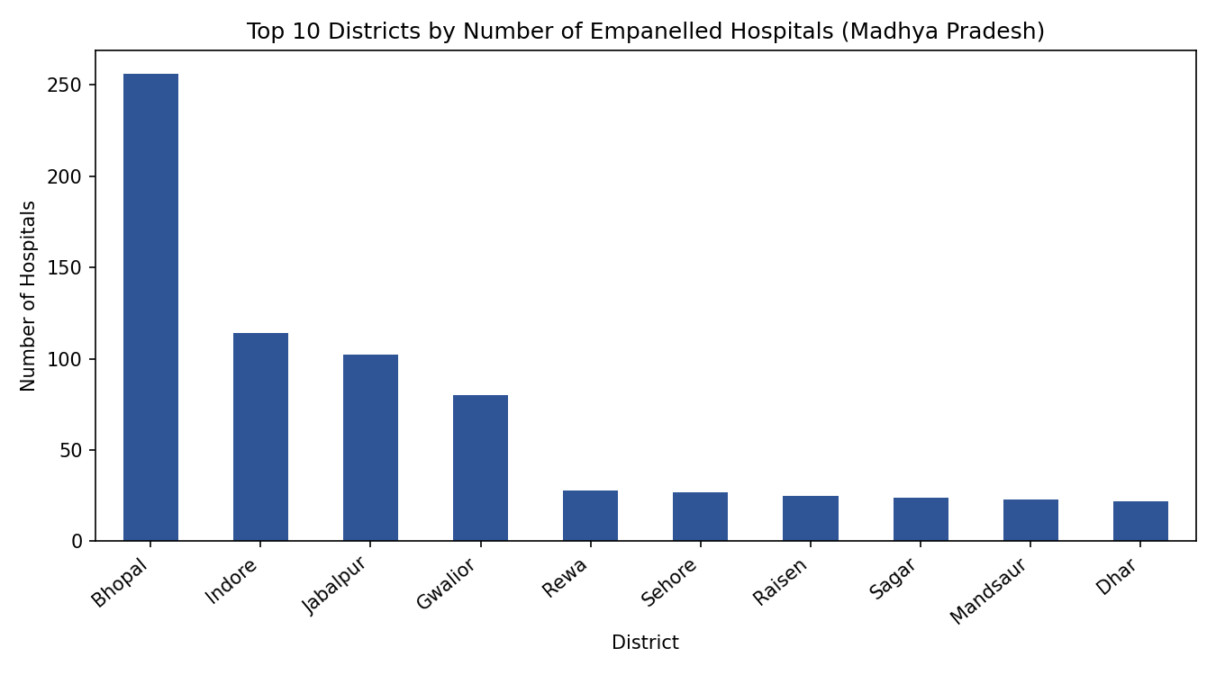
Observation: Bhopal has the most empanelled hospitals (256, or 20.8% of all 1,230), followed by Indore (114), Jabalpur (102) and Gwalior (80). The fifth district, Rewa, has only 28.
Figure 2: Hospital type distribution
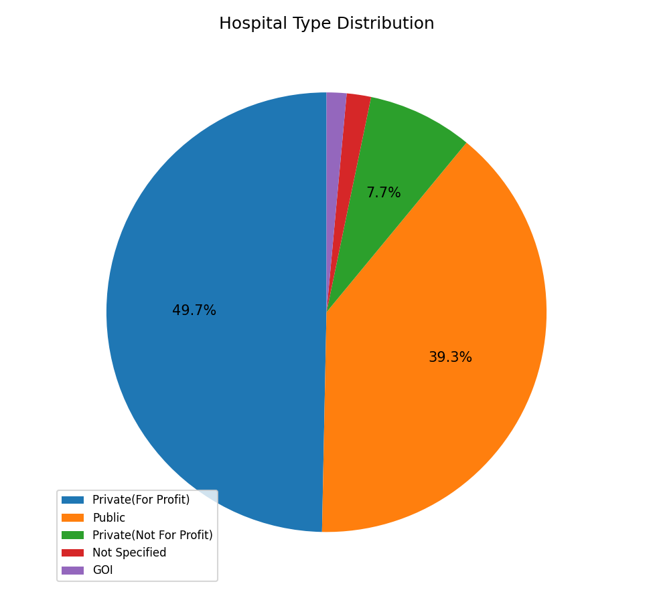
Observation: Private (For Profit) hospitals are the largest group (611, 49.7%), followed by Public (484, 39.3%) and Private (Not For Profit) (95, 7.7%). GOI (18) and unspecified types (22) are small groups.
Figure 3: Distribution of hospitals per district
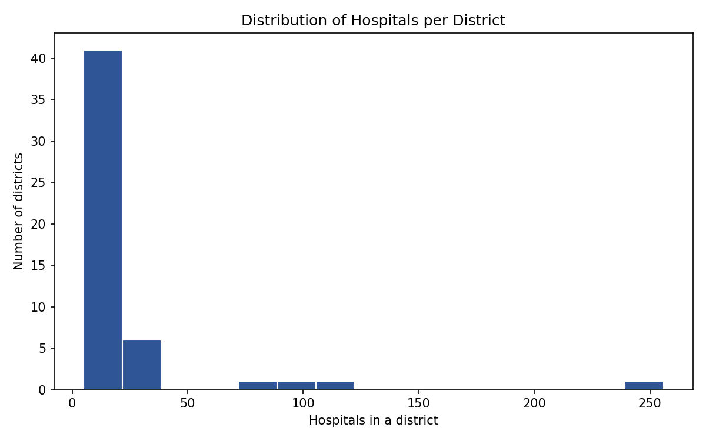
Observation: The distribution is strongly right-skewed. 47 of the 51 districts have fewer than 30 hospitals (median 14), while four districts are far to the right.
Figure 4: Hospital types in the top 8 districts
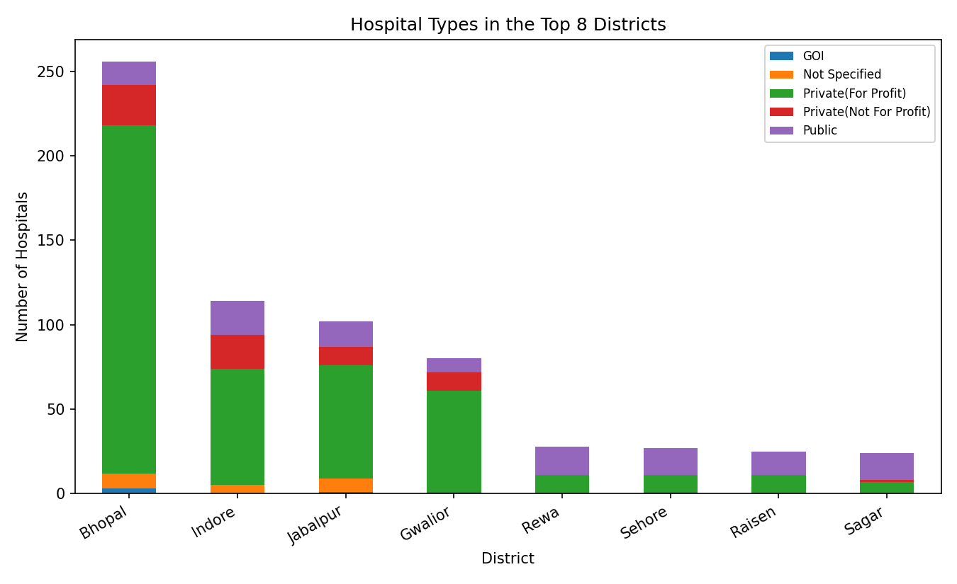
Observation: In Bhopal, 206 of 256 hospitals (80.5%) are private for-profit and only 14 (5.5%) are public. In Rewa, Sehore, Raisen and Sagar the public sector is the largest group (for example, 17 of 28 in Rewa).

6. Statistical Analysis (Basic)
Present basic statistical interpretation — measures of central tendency and spread, correlation coefficients, hypothesis tests, or other relevant statistical techniques used to support the analysis.
Since the data is mainly categorical, the statistics focus on the number of hospitals per district (51 districts): its central tendency (mean, median, mode), spread (standard deviation, coefficient of variation) and how unevenly hospitals are distributed (share of the top 3 districts and the Gini coefficient).
counts = district_counts.values.astype(float)

print("Mean :", round(counts.mean(), 2))
print("Median :", np.median(counts))
print("Mode :", district_counts.mode().iloc[0])
print("Std Dev:", round(counts.std(ddof=1), 2))
print("CV (%) :", round(counts.std(ddof=1) / counts.mean() * 100, 1))
print("Top 3 share (%):", round(counts[:3].sum() / counts.sum() * 100, 1))

# Gini coefficient (0 = equal, 1 = very unequal)
x = np.sort(counts)
k = len(x)
gini = (2 * np.sum(np.arange(1, k + 1) * x) / (k * x.sum())) - (k + 1) / k
print("Gini :", round(gini, 3))

Statistic (hospitals per district) | Value
Mean | 24.12
Median | 14
Mode | 9
Standard deviation | 39.27
Coefficient of variation (%) | 162.8
Minimum / Maximum | 5 (Ashok Nagar) / 256 (Bhopal)
Share of top 3 districts (%) | 38.4
Gini coefficient | 0.497

Interpretation: The mean (24.1) is much higher than the median (14), and the coefficient of variation is very large (162.8%), which shows that a few districts pull the average up. The most common district size is just 9 hospitals. The top 3 districts hold 38.4% of all hospitals, and the Gini coefficient of 0.497 indicates a fairly unequal spread of hospitals across districts. These counts are not adjusted for population, so they show availability, not hospitals per person.

7. Key Insights & Interpretation
List the key insights derived from the analysis and interpret what they mean in the context of the chosen problem statement.
1. Hospitals are concentrated in a few districts: Bhopal alone has 256 hospitals (20.8%), and the top 3 districts hold 38.4% (top 5 hold 47.2%). Beneficiaries in other districts have far fewer empanelled options nearby.
2. Private sector leads in cities, public sector in smaller districts: Private (For Profit) hospitals are 49.7% of all hospitals and 80.5% of Bhopal's, while Rewa (60.7%), Sehore, Raisen and Sagar rely mostly on public hospitals. Access outside the big cities depends heavily on public facilities.
3. Some districts have very low coverage: 14 districts have 9 or fewer empanelled hospitals, with Ashok Nagar (5), Umaria (6), Alirajpur, Datia and Sheopur (7 each) the lowest. These are candidates for attention from healthcare planners, though population size should be checked before drawing firm conclusions.
4. Specialty depth is uneven: hospitals list 5.7 specialty codes on average but the median is 4, and 216 hospitals (17.6%) list one code or fewer. Not-for-profit private hospitals list the most (average 8.2), public hospitals the fewest among the large groups (median 3).
5. Not every listed hospital is a PM-JAY hospital: 154 records (12.5%) are empanelled only under CGHS. Beneficiaries need to filter by empanelment type, which supports the idea of a Smart Health Navigator with State, District, Hospital and Specialty filters.

8. Conclusion & Future Scope
Summarize the overall findings of the project and suggest possible extensions or improvements for future work.
Conclusion: This project cleaned and analysed 1,230 empanelled hospital records for Madhya Pradesh across 51 districts. The analysis shows that hospitals are strongly concentrated in a few districts (top 3 hold 38.4%, Gini 0.497), that private for-profit hospitals dominate cities while public hospitals dominate smaller districts, that 14 districts have 9 or fewer hospitals, and that specialty information varies widely between hospitals. These findings give a clear, data-based view of hospital accessibility instead of an unstructured list.
Future Scope:
- Build a Smart Health Navigator (website or app) with filters for State, District, Hospital and Specialty.
- Decode the specialty codes into specialty names using the official PM-JAY list, and analyse availability of individual specialties by district.
- Add population data to compare hospitals per lakh people, and extend the analysis to other states.
- Add map-based views and track changes in empanelment over time.

9. References
List all references, datasets, articles, and tools cited in the project (use a consistent citation style).
1. National Health Authority (NHA), Government of India, PM-JAY Hospital Search Portal (empanelled hospitals list, Madhya Pradesh). https://hospitals.pmjay.gov.in/Search/empnlWorkFlow.htm
2. National Health Authority (NHA), Government of India, "Ayushman Bharat PM-JAY." https://pmjay.gov.in/
3. Government of India, "Open Government Data (OGD) Platform India." https://data.gov.in/
4. HexaHealth, "Ayushman Bharat Hospitals List in Madhya Pradesh" (used for initial topic selection). https://www.hexahealth.com/hospitals/insurance/ayushman-bharat-hospitals-list-madhya-pradesh
5. Pandas and Matplotlib official documentation. https://pandas.pydata.org/docs/ and https://matplotlib.org/stable/

10. AI Tool Usage Declaration
As per Section 4 & 15 of the PBL guidelines, any use of AI tools (e.g., ChatGPT, GitHub Copilot, Google Colab AI, Gemini, Claude) must be transparently declared below.
☐ No AI tools were used in this project.
☒ AI tools were used, as detailed below:
AI Tool Used | Purpose (e.g., debugging, documentation) | Extent of Use / Section Applied
Claude (Anthropic) | Drafting the report text, writing the Pandas/Matplotlib code, and running the analysis to produce the numbers and charts | Report Sections 1–9; notebook code for Sections 3–6 [edit to match your actual use]

11. Project Links & Deliverables
GitHub Repository Link: https://github.com/rayeenzaki744-spec/ayushman-bharat-healthcare-analytics
Python Notebook (.ipynb) File Name: ayushman bharat analysis.ipynb
PBL Report File Name: PBL Report Ayushman Bharat Healthcare Analytics.docx
Confirm that the GitHub repository includes the code, notebook, and a PBL report as required.
☐ GitHub repository includes code, notebook, and a PBL report and README

12. Report Structure Checklist (Section 8 Compliance)
S. No. | Report Section (as per Section 8 format) | Included (✓)
1 | Title Page | ✓
2 | Introduction & Problem Statement | ✓
3 | Dataset Description & Source | ✓
4 | Data Cleaning & Preprocessing | ✓
5 | Exploratory Data Analysis (EDA) | ✓
6 | Data Visualization & Observations | ✓
7 | Statistical Analysis (Basic) | ✓
8 | Key Insights & Interpretation | ✓
9 | Conclusion & Future Scope | ✓
10 | References | ✓

13. Declaration by Student(s)
I/We hereby declare that this Mini Project Report is our own original work, prepared using publicly available/open datasets. All sources of data, references, and AI tool assistance have been duly acknowledged. I/We understand that any instance of plagiarism in code or report will attract strict academic action, as per Section 15 of the PBL guidelines.
Team Leader Signature: _____________________________________
Team Member Signature(s): _____________________________________
Date: _____________________________________

14. For Faculty Use Only — PBL Final Report Evaluation
Evaluation Component B — PBL Final Report Submission | Mid-Term (PBL Based): 10 Marks (Section 10 of PBL Guidelines)
Evaluation Criteria | Max Marks | Marks Awarded
Data Cleaning & Preprocessing | 2
Exploratory Data Analysis (EDA) | 2
Visualization & Observations | 2
Statistical Analysis | 2
Insights, Interpretation & Conclusion | 2
Total (out of 10) | 10

Faculty Remarks:
______________________________________________________________________
______________________________________________________________________
Faculty Mentor Signature: _____________________________________
Date: _____________________________________

